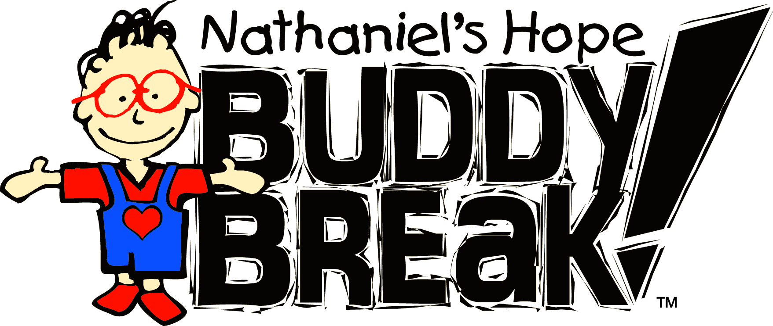
July, August &
September 2018
See other side for Buddy Break dates.
FLORIDA
Calvario City Church (Iglesia El Calvario)  2500 W Oak Ridge Rd  Orlando, FL 32809  407-351-4151  Reserve@ElCalvarioBuddyBreak.com  Casa Sobre la Roca  2149 Orinoco Drive  Orlando, Fl 32836  407-535-3510  City Church  1711 S. Orange Boulevard  Sanford, FL 32771  407-321-9600  buddybreak@citychurchfl.org  First Baptist Church of Orlando  3000 S John Young Pkwy  Orlando, FL 32805  407-514-4295  Shemmi-7@hotmail.com  First Presbyterian Church  117 S Center St  Eustis, FL 32726  352-357-2833  eustisbuddybreak@yahoo.com  Iglesia Cristiana de Adoracion  1557 N. Chickasaw Trail  Orlando, FL 32825  407-658-8506  St. Luke’s United Methodist  4851 S Apopka Vineland Rd  Orlando, FL 32819  407-876-4991, ext. 262  BuddyBreak@st.lukes.org | Calvary Assembly  1199 Clay Street  Winter Park, FL 32789  407-644-1199, ext. 8062  BuddyBreak@CalvaryOrlando.org  Christ Presbyterian Church  1035 W. Granada Blvd.  Ormond Beach, FL 32174  386-677-4076  cpcbuddy@gmail.com  Discovery Church  4400 S Orange Ave  Orlando, FL 32806  321-209-2476  BuddyBreakDiscoveryChurch@gmail.com  First Baptist Church of Merritt Island  140 Magnolia Ave  Merritt Island, FL 32952  321-720-6017  buddybreak@fbcmi.com  Hope International Church  13806 State Rd 33  Groveland, FL 34736  Mosaic Church  14175 W. Colonial Dr  Winter Garden, FL 34787  407-587-9480  kerriannh@thisismosaic.org  Tuskawilla Presbyterian Church  3600 W State Rd 426  Oviedo, FL 32765  407-671-4173  BuddyBreak@myTPC.org | Calvary Baptist Church  2980 N Wickham Rd  Melbourne, FL 32935  321-549-7119  BuddyBreak@CalvaryBaptistMelbourne.org  Church in the Son  4484 N John Young Pkwy  Orlando, FL 32804  321-946-7587  407-301-5360  CITSBuddyBreak@gmail.com  Faith Assembly  9307 Curry Ford Rd  Orlando, FL 32825  407-275-8790  specialblessings@faithassembly.org  First Baptist Church of Windermere  300 Main St  Windermere, FL 34786  407-579-0489  Accept@FBCWindermere.com  Iglesia De Dios  Camino Verdad Y Vida  4114 S Goldenrod Rd  Orlando, FL 32822  407-610-0599  BuddyBreakIglesiadeDios@yahoo.com  Northland, A Church Distributed  530 Dog Track Rd  Longwood, FL 32750  407-937-1828  BuddyBreak@Northlandchurch.net  Vital Church (River of Life)  281 N. Division St.  Oviedo, FL 32765  407-365-5557  buddybreak@theriverorlando.com
Follow us on
@NathanielsHope

July  Saturday, July 7  Calvary Baptist  City Church  Iglesia de Dios Camino Verdad y Vida  Saturday, July 14  Calvary Assembly  Church in the Son  Northland  Friday, July 20  First Baptist Windermere  Friday, July 27  Casa Sobre la Roca  Saturday, July 28  Faith Assembly  Please contact for dates  CrossLife Church  First Presbyterian Eustis  Christ Presbyterian Church  First Baptist Merritt Island  No Buddy Break  Calvario City Church (Iglesia el Calvario)  Discovery Church  First Baptist Orlando  Iglesia Cristian de Adoracion  Mosaic Church  St. Luke’s United Methodist  Tuskawilla Presbyterian  Vital Church (River of Life)  *Dates and times subject to change. Make sure you call the location to make a reservation! | August  Saturday, August 4  Calvary Baptist  City Church  Iglesia de Dios Camino Verdad y Vida  St. Luke’s United Methodist  Saturday, August 11  Calvario City Church (Iglesia el Calvario)  Calvary Assembly  Discovery Church  Iglesia Cristian de Adoracion  Northland  Tuskawilla Presbyterian  Saturday, August 18  Church in the Son  CrossLife Church  Faith Assembly  First Baptist Orlando  First Baptist Windermere  Mosaic Church  Friday, August 31  Casa Sobre la Roca  Please contact for dates  Christ Presbyterian Church  First Baptist Merritt Island  Vital Church (River of Life)  No Buddy Break  First Presbyterian Eustis | September  Saturday, September 1  CrossLife Church  St. Luke’s United Methodist  Saturday, September 8  Calvary Baptist  Calvario City Church (Iglesia el Calvario)  Calvary Assembly  City Church  Discovery Church  Iglesia de Dios Camino Verdad y Vida  Northland  Tuskawilla Presbyterian  Saturday, September 15  First Baptist Orlando  Iglesia Cristian de Adoracion  Mosaic Church  Friday, September 21  First Baptist Windermere  Saturday, September 22  Church in the Son  Hope International Church  Friday, September 28  Casa Sobre la Roca  Saturday, September 29  Faith Assembly  Please contact for dates  Christ Presbyterian Church  First Baptist Merritt Island  First Presbyterian Eustis  Vital Church (River of Life)

